My Pair's Preliminary Project Proposal
Airline Flight Delay Pattern Analysis: A Multi-Dimensional
Attribution Study of U.S. Domestic Flights
Research Question: What drives U.S. domestic flight delays — carriers, airports, time of year, or causal factors?
Team: MC636087 ZHOU ZHUO, MC636011 WANG YU MENG
Preliminary Project Proposal — Ideation
Element | Detail
Region | United States of America (national scope)
Domain Category | Transportation / Aviation — On-Time Performance & Delay Attribution
Research Question | What drives U.S. domestic flight delays — carriers, airports, time of year, or causal factors — and how can travelers, airlines, and policy makers use these insights to improve on-time performance?
Dataset Link 1 (Kaggle) | https://www.kaggle.com/datasets/daryaheyko/airline-on-time-statistics-and-delay-causes-bts
Dataset Link 2 (BTS official) | https://www.transtats.bts.gov
Justification — How the Visualisations Address the Research Question
The four visualisations jointly operationalise the research question along its four analytical dimensions. The carrier-delay ranking (Figure 1) answers “who” by surfacing a 24-percentage-point spread between the best and worst carriers, turning intuition into defensible carrier-selection guidance. The top-delay airports chart (Figure 2) answers “where” by ranking fifteen airports above 27% delay rate, exposing concentrations in weather-vulnerable or infrastructure-constrained locations. The monthly-trend chart (Figure 4) answers “when” by isolating the June peak (23.1%) and September trough (14.9%) — a clear seasonal signal for travel-timing advice. The weather-vs-carrier chart (Figure 3) answers “why” by disaggregating cause mix across major carriers, demonstrating that weather is a minor direct contributor (3.6% system-wide) while carrier operations dominate (~29.5%), redirecting intervention toward operational management rather than weather mitigation.
1. Project Topic Name
Project Topic : Airline Flight Delay Pattern Analysis — A Multi-Dimensional Attribution Study of U.S. Domestic Flights.
Research Question: What drives U.S. domestic flight delays — carriers, airports, time of year, or causal factors?
2. Project Purpose
2.1 Outcomes
Directly delivers on CISC7204's central learning outcome — performing an end-to-end analysis on real data and producing an evidence-based narrative. Reinforces the Data Science major's core workflow (acquisition → cleaning → EDA → visualisation → interpretation) and mirrors the role of an industry analyst who turns operational data into business-relevant recommendations.
2.2 Skills
- Python data analysis (Pandas: groupby, aggregation, imputation, feature engineering).
- Ratio metrics (delay rate, cause share) for standardised cross-group comparison.
- Multi-dimensional thinking (4D matrix: Carrier × Airport × Time × Cause).
- Visual communication (Matplotlib/Seaborn, 150 DPI, colour coding, value labels).
- Reproducible research (annotated Jupyter Notebook, documented assumptions).

2.3 Knowledge
- Aviation domain — four canonical delay causes (carrier, weather, NAS, security) and their shares.
- Bias recognition — minimum-sample thresholds to tame small-sample volatility.
- Time-series fundamentals — seasonal patterns driven by weather and demand cycles.
3. Project Tasks
Nine concrete steps with explicit deliverables, archived in the shared project folder.
Step | Action & Deliverable
1. Data Acquisition | Download BTS Airline On-Time dataset from Kaggle; record ≥ 2 source links.
2. Inspection & Cleaning | Audit missing values; document imputation (carrier_ct, weather_ct → 0).
3. Feature Engineering | Build delay_rate, weather_share, carrier_share (zero-division guarded).
4. Carrier Analysis | Rank by delay_rate (flights > 10,000); produce carrier_delay_ranking.png.
5. Airport Analysis | Rank by delay_rate (flights ≥ 500); produce top_delay_airports.png.
6. Temporal Analysis | Monthly delay rates; produce monthly_trend.png with peak annotation.
7. Causal Analysis | Cause proportions + per-carrier weather vs carrier shares; produce weather_vs_carrier.png.
8. Interpretation | Stakeholder-specific recommendations (travelers, airlines, airports, FAA).
9. Integration | Compile DOCX; run notebook end-to-end; archive outputs.
4. Criteria for Success
Six measurable criteria; each carries explicit evidence.
Criterion | Definition of Done & Evidence
Data Integrity | Missing values treated with documented business-logic imputation. Evidence: §4 / notebook comments.
Analytical Depth | Interpretation explains “why” each pattern emerges, not just numbers. Evidence: §6 + §7.
Visualisation Quality | Title, axis labels, value annotations, legend, 150 DPI, purposeful colour. Evidence: 4 embedded PNGs.
Actionable Outputs | Stakeholder-specific recommendations. Evidence: §8 stakeholder table.
Reproducibility | Notebook runs end-to-end without errors; commented code committed to GitHub. Evidence: .ipynb file.
Proposal Completeness | All 5 required components (Topic, Purpose, Tasks, Criteria, Collaboration). Evidence: §1–§5 of this report.
5. Project Collaboration
Division of Work
Member / Role | Core Responsibilities
Member A — Coordinator & Data Analyst | Timeline & progress tracking; data loading / cleaning / feature engineering; carrier & airport analyses; carrier & airport charts; code integration; primary instructor liaison.
Member B — Researcher & Report Writer | Cause & temporal analyses; cause & trend charts; proposal & report writing; meeting minutes & decision log; code review and testing support.
6. Data Analysis Report
6.1 Executive Summary & Key Findings
Analyses U.S. domestic flight delays using the U.S. BTS Airline On-Time Statistics dataset (Kaggle), which contains 398,233 aggregated records summarizing flight activity from June 2003 to January 2025. These records represent over 140 million actual domestic flights.
A multi-dimensional framework (carrier, airport, time, cause) is applied to investigate delay determinants. Overall delay rate is 19.2%; carrier operations are the largest identifiable cause (29.5%); weather contributes only 3.6% directly; September is the most reliable travel month (14.9%) and June the worst (23.1%). The four visualisations below operationalise the research question's four analytical dimensions.
Indicator | Value
Overall delay rate | 19.2%
Most punctual carrier | Aloha Airlines Inc. — 7.1%
Least punctual carrier | Peninsula Airways Inc. — 31.5%
Most delay-prone airport | Unalaska, AK — 37.1%
Carrier-caused delay share | 29.5% (largest identifiable cause)
Weather-caused delay share | 3.6%
Best travel month | September — 14.9%
Worst travel month | June — 23.1%
6.2 Carrier Analysis (Who, RQ1)
Based on aggregation over the entire 2003–2025 dataset (filtering carriers with >10,000 total flights), the top 5 most punctual carriers are:Aloha Airlines 7.1%, Hawaiian 7.8%, Cape Air 8.9%, Endeavor Air 13.8%, Horizon Air 14.3%. Bottom 5: Peninsula Airways 31.5%, Frontier 26.2%, JetBlue 24.4%, Allegiant 23.7%, Spirit 23.6%. Hawaiian carriers benefit from stable tropical weather and short-haul island operations; Peninsula's poor performance reflects remote Alaska weather and infrastructure constraints. Spread of 24.4 percentage points confirms carrier choice is consequential.
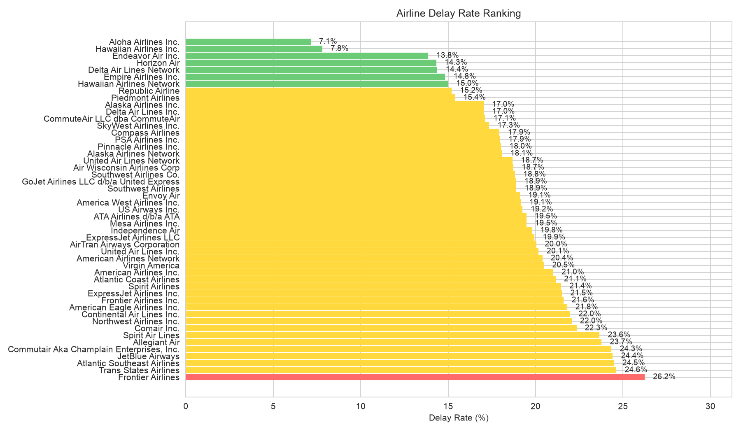
Figure 1 — Carrier delay-rate ranking (green <15%, yellow 15–25%, red >25%).

6.3 Airport Analysis (Where, RQ2)
Top high-delay airports: Unalaska 37.1%, Wilmington 32.4%, Salem 31.9%, Macon 31.6%, Aguadilla 28.7%. Two clusters emerge: remote/underserved (Unalaska, Presque Isle) and climate-vulnerable (Aguadilla, Punta Gorda). All exceed the 19.2% national average by ≥9 percentage points.
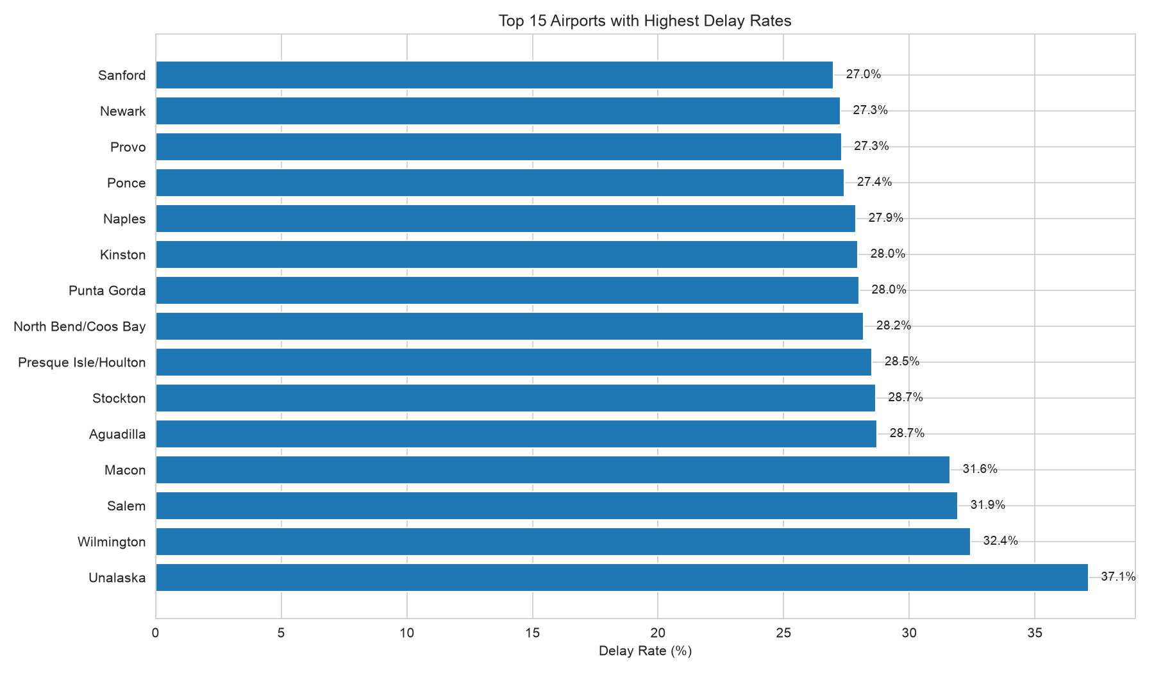
Figure 2 — Top 15 high-delay airports.
6.4 Causal Analysis — Aggregate (Why, RQ4)
Aggregate cause distribution: Carrier 8,166,343 (29.5%); Weather 997,212 (3.6%); Other (NAS / Security / Late aircraft / System) 18,484,937 (66.9%); Total 27,648,492. “Other” dominates, underscoring systemic complexity. The largest identifiable contributor is carrier operations — fleet, crew, and maintenance management are the critical improvement levers. Weather is a minor direct cause despite popular perception.
6.5 Causal Analysis — Carrier-Level (RQ5)
Top 10 carriers by weather-delay share: Comair 18.5%, Atlantic Southeast 9.4%, Virgin America 8.7%, Peninsula Airways 6.9%, Envoy Air 6.3%, Piedmont 5.8%, Allegiant 5.7%, SkyWest 5.1%, Northwest 4.9%, American Eagle 4.9%. Comair's high weather exposure reflects its Midwest/Southeast route structure. Carriers should match mitigation strategy to cause profile: operational optimisation for carrier-dominated delays, route planning & forecasting for weather-dominated ones.
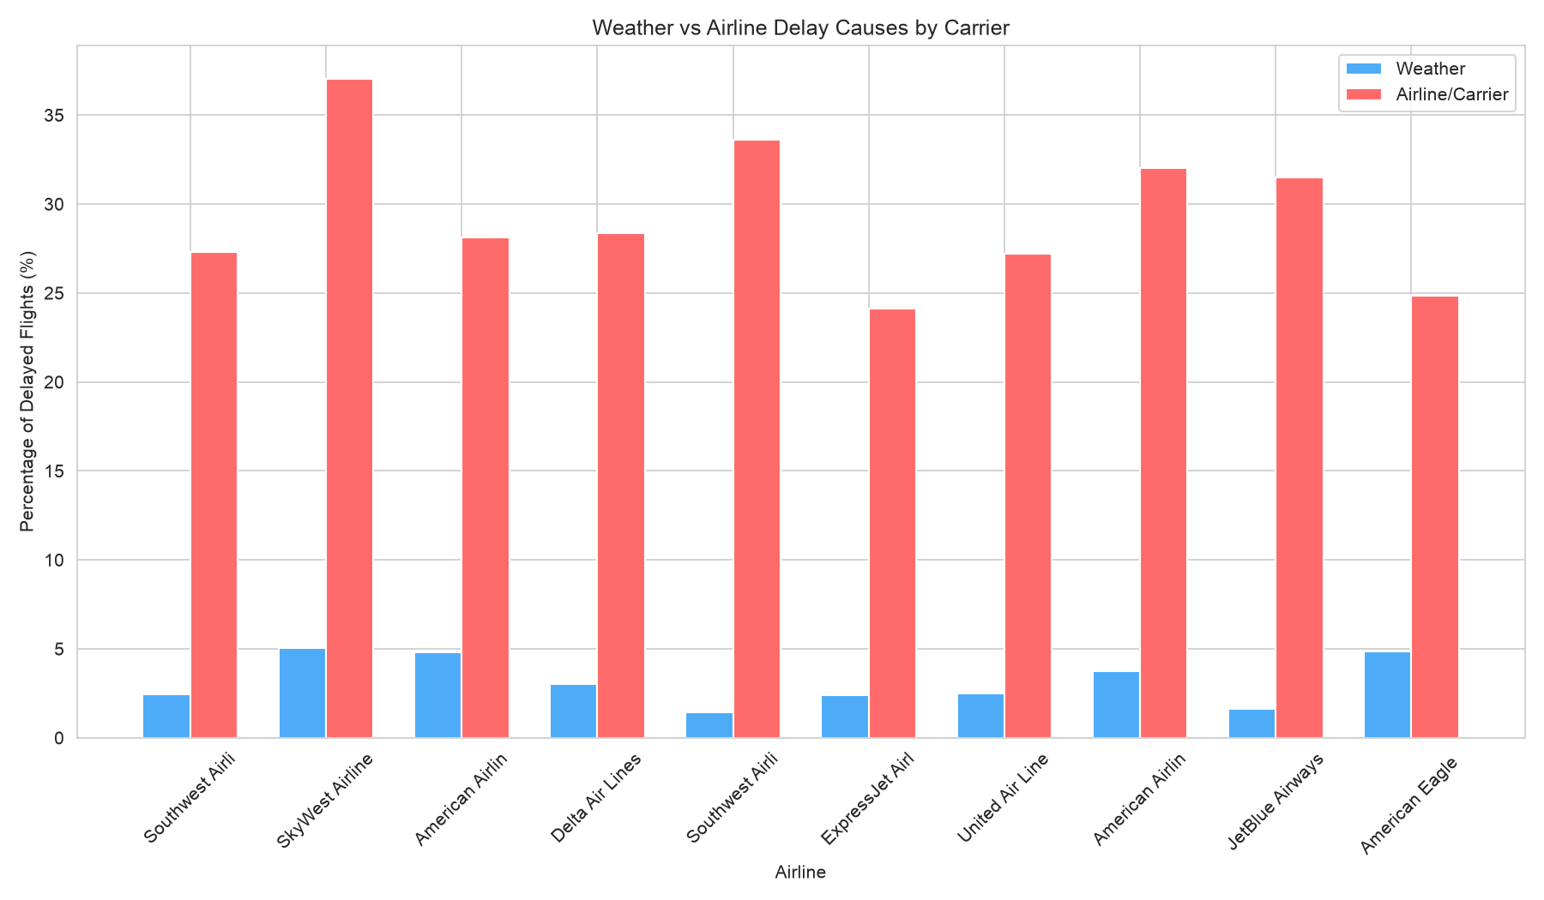
Figure 3 — Weather vs airline delay causes by carrier (top carriers by delay volume).

6.6 Temporal Analysis (When, RQ3)
Monthly delay rates follow a clear unimodal pattern: low in winter, rising through spring, peaking in June (23.1%) on combined summer-storm and peak-demand stress, then sharply dropping to September (14.9%) as demand falls and weather stabilises. Range = 8.2 pp — large enough to support timing-based travel advice.
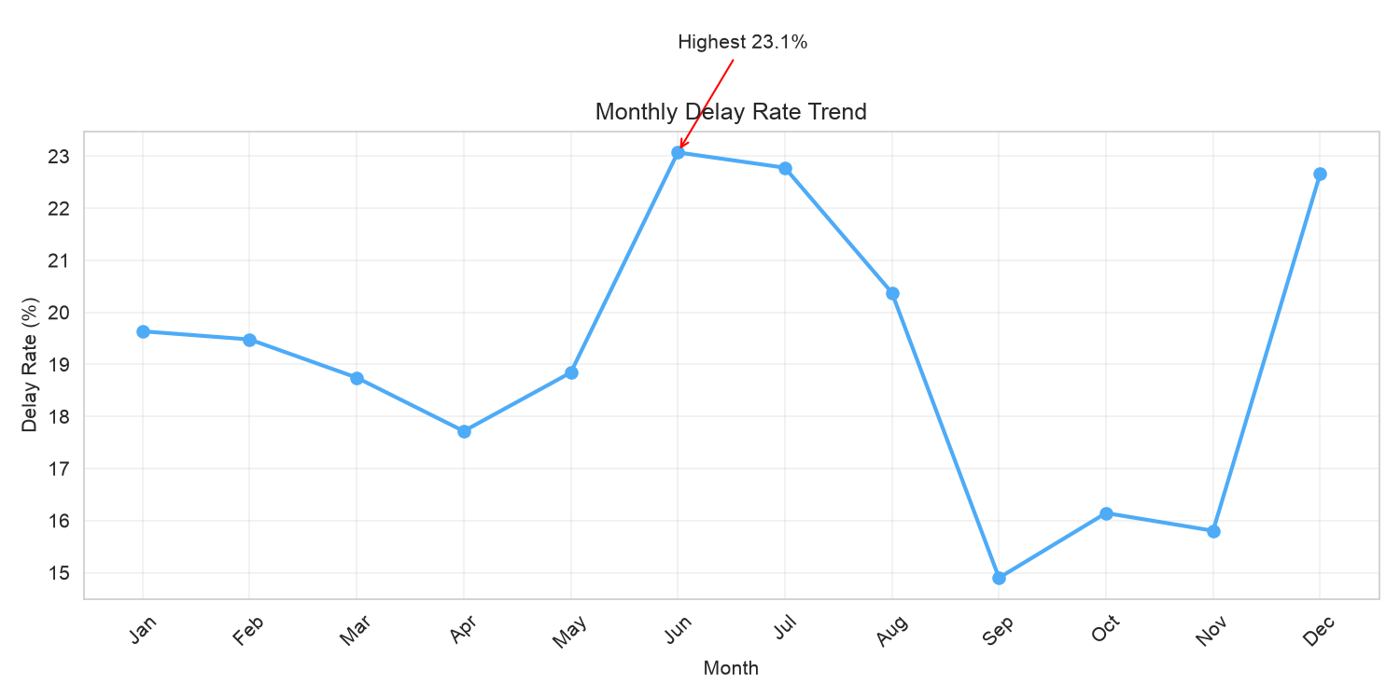
Figure 4 — Monthly delay rate trend with annotated maximum.
7. Discussion & Conclusion
7.1 Principal Conclusions
- Carrier choice is consequential — a 24.4 pp spread between best and worst.
- Operational management is the key lever — 29.5% carrier + 66.9% other = 96.4% within operational reach.
- Weather is a minor direct cause (3.6%) — over-emphasised in public perception.
- September is the optimal travel month (14.9% delay rate).
7.2 Stakeholder Recommendations
Stakeholder | Recommendation | Evidence
Travelers | Choose punctual carriers (Aloha, Hawaiian); avoid high-delay airports; travel in September. | 7.1% vs 31.5% carrier spread; 37.1% airport peak; 14.9% vs 23.1% monthly.
Airlines | Optimise crew scheduling & maintenance; build weather preparedness for high-exposure routes (Comair); add slack in May–Aug. | 29.5% carrier share; Comair 18.5% weather share; 23.1% June peak.
Airports | Invest in weather monitoring & de-icing at remote hubs (Unalaska); improve ground handling. | Remote airports > 28% delay.
FAA / Policy | Modernise NAS (NextGen) to address 66.9% “Other”; reduce cascading delays via system coordination. | “Other” dominates at 66.9%.
7.3 Limitations & Future Work
Limitations: The data are pre-aggregated (monthly counts per carrier and airport), which prevents micro-level analysis such as daily weather event impacts or aircraft-specific turnaround efficiency. The "Other" category (66.9%) bundles NAS (National Airspace System), security, and late-arriving aircraft without further breakdown, limiting our ability to pinpoint systemic causes. Small airports and carriers exhibit high rate volatility, which we mitigated by applying minimum sample thresholds (≥500 flights for airports, ≥10,000 total flights for carriers) in the visualizations.
Future work: Leverage the full 22-year longitudinal span for forecasting models (e.g., ARIMA, LSTM) to predict delay probabilities; attempt to disaggregate the "Other" category using machine learning on more granular data (if available); conduct spatial analysis of delay propagation across airport networks; and quantify the economic impact of delays on passengers and airlines.
7.4 References
[1] U.S. Bureau of Transportation Statistics. (2025). Airline On-Time Statistics and Delay Causes. Washington, DC: U.S. Department of Transportation. Available via Kaggle: https://www.kaggle.com/datasets/daryaheyko/airline-on-time-statistics-and-delay-causes-bts
[2] BTS Airline Service Quality Performance database. https://www.transtats.bts.gov
[3] FAA (2024). NextGen Implementation Plan. [4] Ball et al. (2010). Total Delay Impact Study, NEXTOR. [5] U.S. GAO (2023). Airline Delay Causes and Mitigation Strategies. GAO-23-104782.

